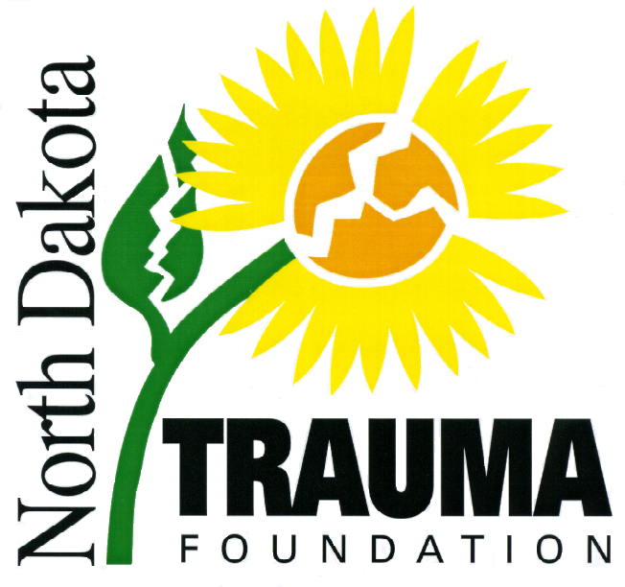

Thank you for your interest in the North Dakota Trauma Foundation (NDTF) grant program. The NDTF grant program is funded through individual/squad memberships and proceeds from the annual North Dakota State-Wide Trauma Conference.

The committee that reviews the grant applications consists of members of the NDTF Board of Directors, including a surgeon, emergency room physician, emergency room RN, trauma coordinator, hospital administrator, RNs, pre-hospital provider, air medical service representative, advanced practice provider, and interested lay persons. In previous years grant funds have been used for education, equipment, and injury prevention projects. Please note that grant funds are awarded only to projects that are specifically related to trauma.

To fund as many projects as possible, NDTF provides funding on a 1:1 match basis. The NDTF grant funds can be used for up to half of the total cost of the project, and the requesting agency is responsible for the remaining cost. Each grant award will not exceed $1000.00. If you feel your project is especially worthy, and that the NDTF should consider funding greater than 50% of the total cost up to $1000.00, please include the details of your exceptional circumstances or needs in your application. Priority for grant awards may also be given to agencies that have previously supported the NDTF.

Please be aware that incomplete grant applications will not be considered. All requested information must be included with the application. Members of the grant committee may contact you if there are any questions regarding your application. If you have any questions or concerns, please contact Vicky Black (701) 364-8424, Amy Eberle (701) 323-2939, or Deb Syverson (701) 417-2109.

Grant awards will be announced at the annual North Dakota State-Wide Trauma Conference. A letter will be sent to the e-mail address provided on the application to officially notify you of any grant award from the NDTF and will explain the grant award requirements.

Please submit your completed grant application and supporting documentation to:
North Dakota Trauma Foundation
1622 East Interstate Avenue
Bismarck, ND 58505

Completed applications may also be e-mailed to Vicky Black at victoria.black@essentiahealth.org. All applications must be received by Friday, August 29, 2025, to be considered.

Sincerely,

Vicky Black, RN, BSN
President, North Dakota Trauma Foundation

North Dakota Trauma Foundation

Grant Application 2025
Please type or print legibly.
Page 1

- Name of Organization:

- Contact Person:

- Organization Mailing Address:

City/State/Zip Code:

Telephone Number (include area code):

E-mail address:
4. Specify the equipment/materials that would be purchased with grant funds, or what type of training/education will be provided:

***Pre-hospital requests for equipment require a letter of support from the organization’s medical director.

- The specific amount requested from the NDTF not to exceed $1000: $
***Attach a detailed, itemized list of the total cost of all items.

- Attach the most recent complete fiscal year or calendar year budget for your total operating budget. Please include a balance sheet that includes cash assets and net revenue.

- Your organization History (Describe the history of your organization):

- Your organization’s role in the community:

9. Description of Need (Please provide a description of the need or problem to be addressed and the specific purpose of the funds requested):

10. Number of people employed by your organization:

If you are an EMS service, what is your average number of runs per year?

If you are a health care facility, what is your average number of ER visits per year?

- Describe how additional funding will be raised or other sources of funding available to you to complete the cost of your project:

Organization Representative Name & Title (please print):

Signature: Date:

